Graph Planarity

A graph G is planar if it can be drawn in the plane in such a way that no two edges meet each other except at a vertex to which they are incident. Any such drawing is called a plane drawing of G.

For example, the graph K₄ is planar, since it can be drawn in the plane without edges crossing.

The three plane drawings of K₄ are:

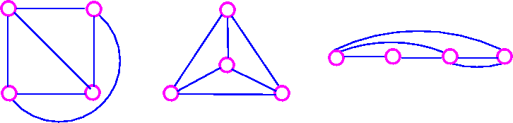

The five Platonic graphs are all planar.
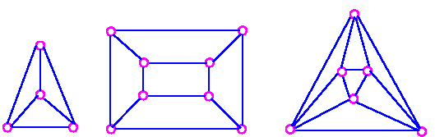
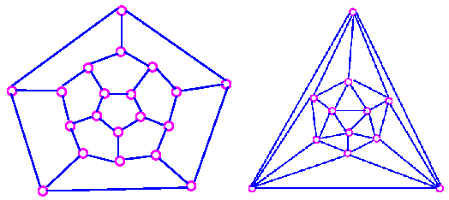

On the other hand, the complete bipartite graph K_{3,3} is not planar, since every drawing of K_{3,3} contains at least one crossing. why? because K_{3,3} has a cycle which must appear in any plane drawing.
To study planar graphs, we restrict ourselves to simple graphs.
- If a planar graph has multiple edges or loops.
  - Collapse the multiple edges to a single edge.
  - Remove the loops.
- Draw the resulting simple graph without crossing.
- Insert the loops and multiple edges.

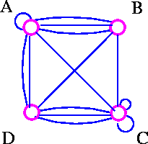

Remove loops and multiple edge.

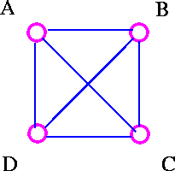

Draw without multiple edge.

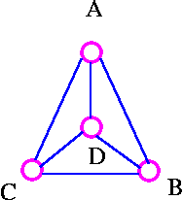

Insert loops and multiple edges.
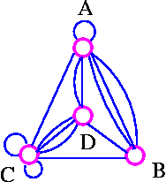

Euler's Formula
If G is a planar graph, then any plane drawing of G divides the plane into regions, called faces. One of these faces is unbounded, and is called the infinite face. If f is any face, then the degree of f (denoted by deg f) is the number of edges encountered in a walk around the boundary of the face f. If all faces have the same degree (g, say), the G is face-regular of degree g.
For example, the following graph G has four faces, f₄ being the infinite face.

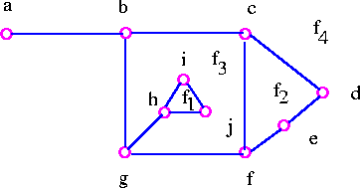

It is easy to see from above graph that deg f₁=3, deg f₂=4, deg f₃=9, deg f₄=8.

Note that the sum of all the degrees of the faces is equal to twice the number of edges in the the graph , since each edge either borders two different faces (such as bg, cd, and cf) or occurs twice when walk around a single face (such as ab and gh). The Euler's formula relates the number of vertices, edges and faces of a planar graph. If n, m, and f denote the number of vertices, edges, and faces respectively of a connected planar graph, then we get n-m+f = 2.
The Euler formula tells us that all plane drawings of a connected planar graph have the same number of faces namely, 2+m-n.

Theorem 1 (Euler's Formula) Let G be a connected planar graph, and let n, m and f denote, respectively, the numbers of vertices, edges, and faces in a plane drawing of G. Then n - m + f = 2.

Proof We employ mathematical induction on edges, m. The induction is obvious for m=0 since in this case n=1 and f=1. Assume that the result is true for all connected plane graphs with fewer than m edges, where m is greater than or equal to 1, and suppose that G has m edges. If G is a tree, then n=m+1 and f=1 so the desired formula follows. On the other hand, if G is not a tree, let e be a cycle edge of G and consider G-e. The connected plane graph G-e has n vertices, m-1 edges, and f-1 faces so that by the inductive hypothesis,
n - (m - 1) + (f - 1) = 2
which implies that
n - m + f = 2.

We can obtains a number of useful results using Euler's formula. (A "corollary" is a theorem associated with another theorem from which it can be easily derived.)

Corollary 1 Let G be a connected planar simple graph with n vertices, where n ≥ 3 and m edges. Then m ≤ 3n - 6.

Proof For graph G with f faces, it follows from the handshaking lemma for planar graph that 2m ≥ 3f (why?) because the degree of each face of a simple graph is at least 3), so f ≤ 2/3 m.
Combining this with Euler's formula
Since n - m + f = 2
We get m - n + 2 ≤ 2/3 m
Hence m ≤ 3n - 6.

As an example of Corollary 1, show that K₅ is non-planar.
Proof Suppose that K₅ is a planar graph. Since K₅ has 5 vertices and 10 edges it follows from Corollary 1 that 10 (3 × 5) - 6 = 9. This contradiction shows that K₅ is non planar.

It is important to note that K_{3,3} has 6 vertices and 9 edges, and it is true that 9 ≤ (3 × 6) - 6 = 12. This fact simply shows that we cannot use Corollary 1 to prove that K_{3,3} is non-planar. This leads us to following corollary.

Corollary 2 Let G be a connected planar simple graph with n vertices and m edges, and no triangles. Then m ≤ 2n - 4.
Proof For graph G with f faces, it follows from the handshaking lemma for planar graphs that 2m ≥ 4f (why because the degree of each face of a simple graph without triangles is at least 4), so that f ≤ 1/2 m.

Combining this with Euler's formula
Since n - m + f = 2
Implies m -n + 2 = f
We get m - n + 2 ≤ 1/2m
Hence m ≤ 2n - 4

As an example of Corollary 2, show that K_{3,3} is non-planar.
Proof Suppose that K_{3,3} is a planar graph. Since K_{3,3} has 6 vertices and 9 edges and no triangles, it follows from Corollary 2 that 9 ≤ (2×6) - 4 = 8. This contradiction shows that K_{3,3} is non-planar.

Corollary 3 Let G be a connected planar simple graph. Then G contains at least one vertex of degree 5 or less.
Proof From Corollary 1, we get m ≤ 3n-6. Suppose that every vertex in G has degree 6 or more. Then we have 2m ≥ 6n (why? because 2m is the sum of the vertex-degree), and therefore m≥3n. This contradiction shows that at least one vertex has degree 5 or less.

Now we will show by using Euler's formula that there are only five regular convex polyhedra - namely, the tetrahedron, cube, octahedron, dodecahedron, and isosahedron.

Theorem 2 There are only 5 regular convex polyhedra.
Proof We prove this theorem by showing that there are only 5 connected planar graph G with following properties.
- G is regular of degree d, where d≥3.
- Any plane drawing of G is face-regular of degree g where g≥3.

Let n, m and f be the numbers of vertices, edges, and faces of such a planar graph G. Then, from properties (i) and (ii), we ge
m = 1/2 dn
= 1/2 gf
This gives us n = 2m/d and f = 2m/g
Here Euler's formula (n - m + f = 2) holds, since G is a planar graph.
Therefore, 2m/d - m + 2m/g = 2
Which can be written as 1/d - 1/2 + 1/g = 1/m
Since 1/m > 0, it follows that 1/d + 1/g > 1/2

Note that each of d and g is at least 3, so each of 1/d and 1/g is at most 1/3.
Therefore, 1/d > 1/2 - 1/3 = 1/6 and 1/g > 1/2 - 1/3 = 1/6.
and we conclude that d < 6 and g < 6.

This means that the only possible values of d and g are 3, 4, and 5. However, if both d and g are greater than 3, then

1/d + 1/g ≤ 1/4 + 1/4 = 1/2

which is a contradiction. This leaves us with just five cases:

Case 1: When d = 3 and g = 3.
we get 1/m = 1/3 - 1/2 + 1/3 = 1/6
Therefore m = 6
It follows that n = 8 and f = 4 and this gives the Tetrahedron.
Case 2: When d = 3 and g = 4.
we get 1/m = 1/3 - 1/2 + 1/4 = 1/12
Therefore m = 12
It follows that n = 8 and f = 6 and this gives the Cube.
Case 3: When d = 3 and g = 5.
we get 1/m = 1/3 - 1/2 + 1/5 = 1/30
Therefore m = 30
It follows that n = 20 and f = 12 and this gives the Dodecahedron.
Case 4: When d = 4 and g = 3.
we get 1/m = 1/4 - 1/2 + 1/3 = 1/12
Therefore m = 12
It follows that n = 6 and f = 8 and this gives the Octahedron.
Case 5: When d = 5 and g = 3.
we get 1/m = 1/5 - 1/2 + 1/3 = 1/30
Therefore m = 30
It follows that n = 12 and f = 20 and this gives the Icosahedron.

And this completes the proof.

Planarity Testing
The Corollaries 1, 2 and their generalization are often useful for showing that graph is not planar. Unfortunately, there are many graphs which satisfy these inequalities but are not planar. Therefore, we need other way to decide planarity.
Some important observations:
- Observation 1
  - Not all graphs are planar.
  - For example, we know K₅ and K_{3,3} are not planar.
- Observation 2
  - If G is a planar graph, then every subgraph of G is planar;
  - We usually stated observation 2 as follows
  - Observation 2a
  - If G contains a nonplanar graph as a subgraph, then G is non-planar. For example, following graph is nonplanar

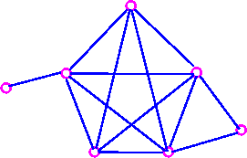
- Since it contains K5 as a subgraph.
- The following graph is also non-planar
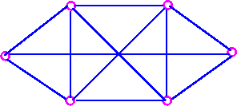
- Since the it contains K_{3,3} as a subgraph.
- Observation 3
  - If G is a planar graph, then every subdivsion of G is planar, we usually stated observation 3 in the following way.
  - Observation 3a
  - If G is a subdivision of a non-planar graph, then G is non-planar.
  - For example, following graph is non-planar,
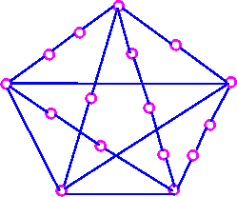
- Since it is a subdivision of K₅.
- Also, the following graph is non-planar,

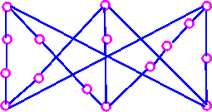
- Since it is a subdivision of K_{3,3}.

It follows from observations (2a) and (3a) that, if any graph G contains a subdivision of K₅ and K_{3,3} as a subgraph, then G must be non-planar.

Why are we so obsessed with K₅ and K_{3,3}? The reason is that all non-planar graphs can be obtained by adding vertices and edges to a subdivision of K₅ and K_{3,3}.
Every non-planar graph contains K₅ or K_{3,3} as a subgraph.

Following result is due to the Polish mathematician K. Kuratowski.

Theorem 3 A graph is planar if and only if it does not contain a subdivision of K₅ and K_{3,3} as a subgraph.

Graph Contraction
In the following figure contradiction is done by bringing the vertex w closer and closer to v until w and v coincide and then coalescing multiple edges into a single edge.

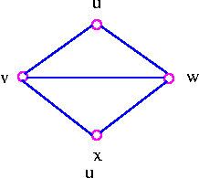
Bring vertex w closer to v.

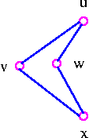
Coalesce vertex v and vertex w.

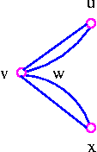
Finally, coalesce multiple edges and we have

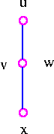

A contraction of a graph is the result of a sequence of edge-contractions. For example, K₅ is a contraction of the Petersen graph

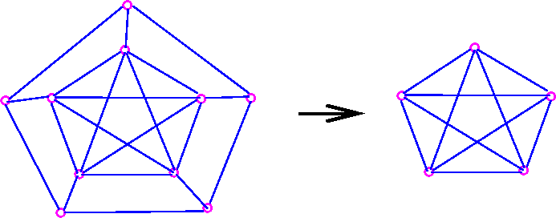

Theorem 4 A graph is planar if and only if it does not contain a subgraph which has K₅ and K_{3,3} as a contraction.

The basic idea to test the planarity of the given graph is if we are able to
spot a subgraph which is a subdivision of K₅ or K_{3,3} or a subgraph which
contracts to K₅ or K_{3,3} then a given graph is non-planar.

Theorems 3 and 4 give us necessary and sufficient conditions for a graph to be planar in purely graph-theoretic sense (subgraph, subdivision, K_{3,3}, etc) rather than geometric sense (crossing, drawing in the plane, etc). This is the reason, why there exists no algorithm uses these two theorems for testing the planarity of a graph. Since this would involve looking at a large number of subgraph and verifying that none of them is a subdivision of, or contracts toK₅ or K_{3,3}.

Duality
Given a connected planar graph G, we construct dual graph G* in three stages.
- Take a plane drawing of G.
- Choose one point inside each face of the plane drawing - these points are the vertices of G*.
- For each e of the plane drawing, draw a line connecting the vertices of G* on each side of e.
This procedure is illustrated as follows:

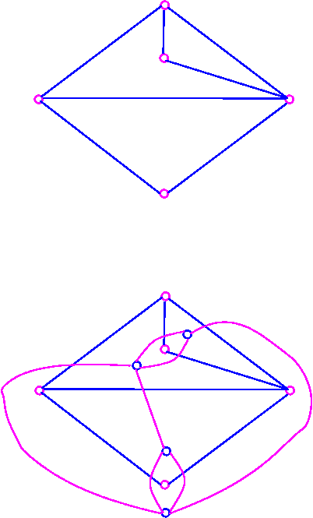

Note that each plane drawing of G given rise to just one dual graph G*.

Following theorem illustrates a simple relationship between the number of vertices, faces and edges of a graph and its dual.

Theorem 6 If G is a connected planar graph with n vertices, f faces and m edges, then G* has f vertices, n faces and m edges.

In the above example, G has 5 vertices, 4 faces and 7 edges, and G* has 4 faces, 5 faces, and seven edges.
Note that if G is a connected planar graph, then G* is also connected planar graph.

